LAB ASSIGNMENT

Name:G.Sudeeksha

Roll No: 2403A510E0

Course : AI Assisted Coding

Branch : CSE

Batch : 05

Q1. Zero-shot Classification

Task 1: Write a zero-shot prompt to classify sentiment without any examples.

Prompt:

#Write a zero-shot prompt to classify sentiment without any examples.

Classify the sentiment of the following text as Positive, Negative, or Neutral:

Text: "I really enjoyed the movie and would watch it again."

Sentiment:

Code Generation:

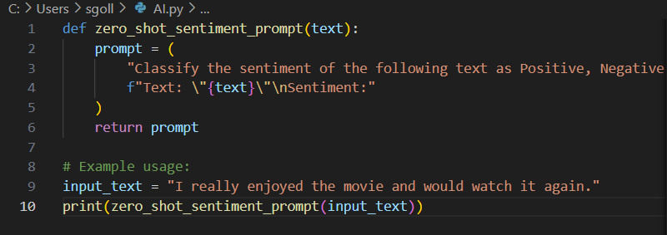

Output:

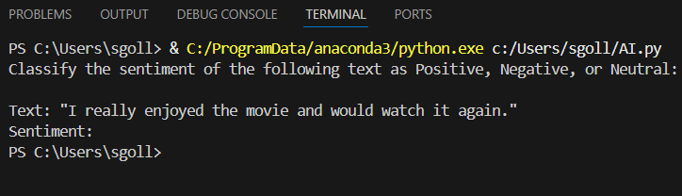

Observation:

The code defines a function zero_shot_sentiment_prompt that constructs a zero-shot prompt for sentiment classification. It takes an input text, formats it into a prompt asking for sentiment (Positive, Negative, or Neutral), and returns the prompt string. The example usage demonstrates how to generate and print the prompt for a sample text. The code does not perform sentiment analysis itself; it prepares the prompt for use with a language model or API.

Task 2: Create a scenario where an AI assistant needs to help a student solve math problems.  
Write two prompts: one without context and one with detailed context (e.g., grade level, topic,  
difficulty).

Prompt:

# Create a scenario where an AI assistant needs to help a student solve math problems.  
give one code without content

Code Generation :

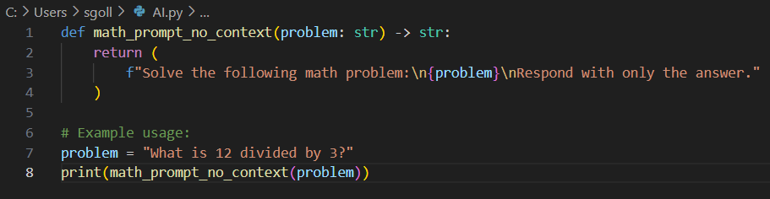

Output :

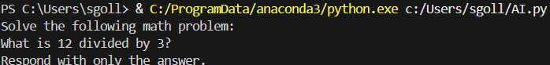

**Observation:**  
The code defines a function math_prompt_with_context that generates a math help prompt including detailed context: grade level, topic, and difficulty. It formats a message as if from a student, asking for help and an explanation of the steps. The example usage demonstrates how to create a prompt for a 5th-grade geometry problem at medium difficulty. This approach helps an AI assistant tailor its response to the student's background and needs.

Prompt for with content:

# Create a scenario where an AI assistant needs to help a student solve math problems.Give code for with content

Code Generation :

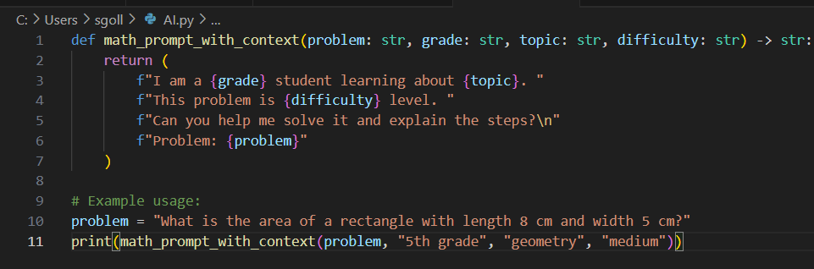

Output:

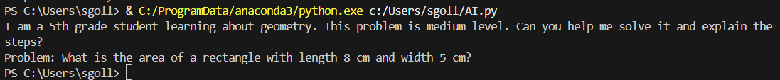

Observation:

The code defines a function math_prompt_with_context that generates a math help prompt including detailed context: grade level, topic, and difficulty. It formats a message as if from a student, asking for help and an explanation of the steps. The example usage demonstrates how to create a prompt for a 5th-grade geometry problem at medium difficulty. This approach helps an AI assistant tailor its response to the student's background and needs.

Q2. One-shot vs Few-shot

Task 1: Write:  
o A one-shot prompt (give 1 example of classification).  
o A few-shot prompt (give 3–4 examples).

Prompt:

#A one-shot prompt (give 1 example of classification).

Code:

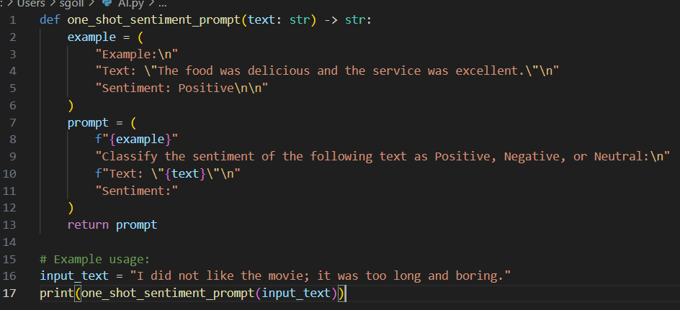

Output:

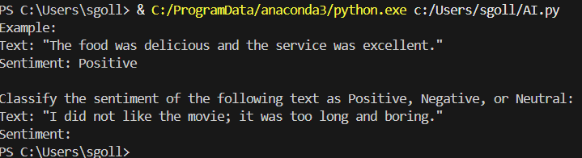

Observation:

The code defines a function one_shot_sentiment_prompt that generates a one-shot prompt for sentiment classification. It includes a single example of a positive sentiment to guide the AI model, followed by a request to classify the sentiment of a new input text. This approach helps the AI understand the expected format and type of response by providing one labeled example before the actual classification task.

Prompt:

#A few-shot prompt (give 3–4 examples).

Code:

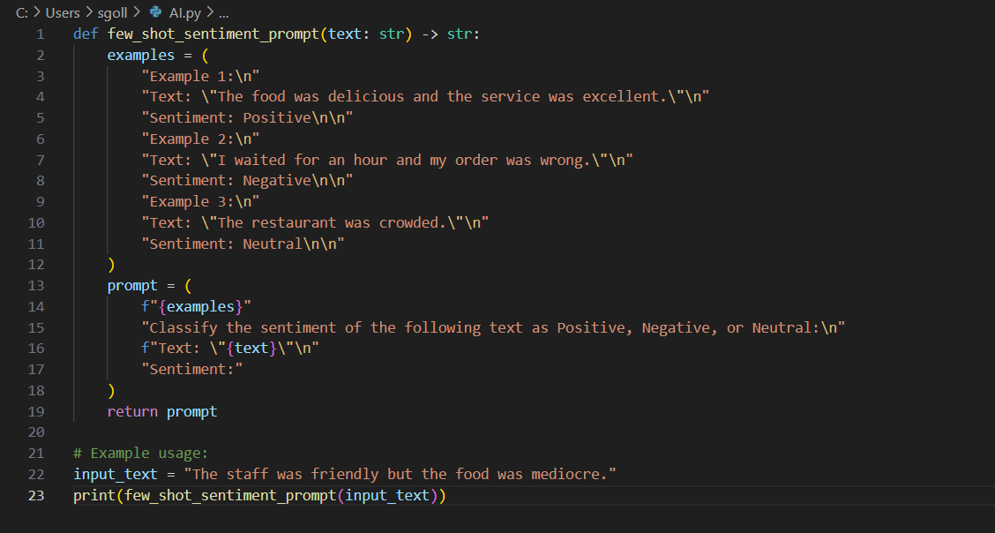

Output:

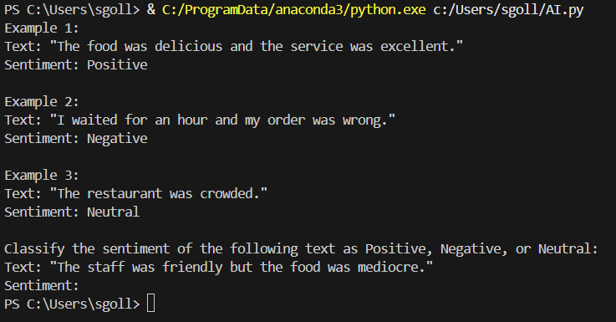

Observation:

The code defines a function few_shot_sentiment_prompt that generates a prompt for sentiment classification using three labeled examples (positive, negative, neutral). By providing multiple examples, the prompt helps the AI model better understand the classification task and expected output format. The function then appends a new input text for classification, making it suitable for few-shot learning scenarios.

Task 2: Compare outputs on the same set of tweets and explain the difference.

Prompt:

# Compare outputs on the same set of tweets and explain the differences.

Code:

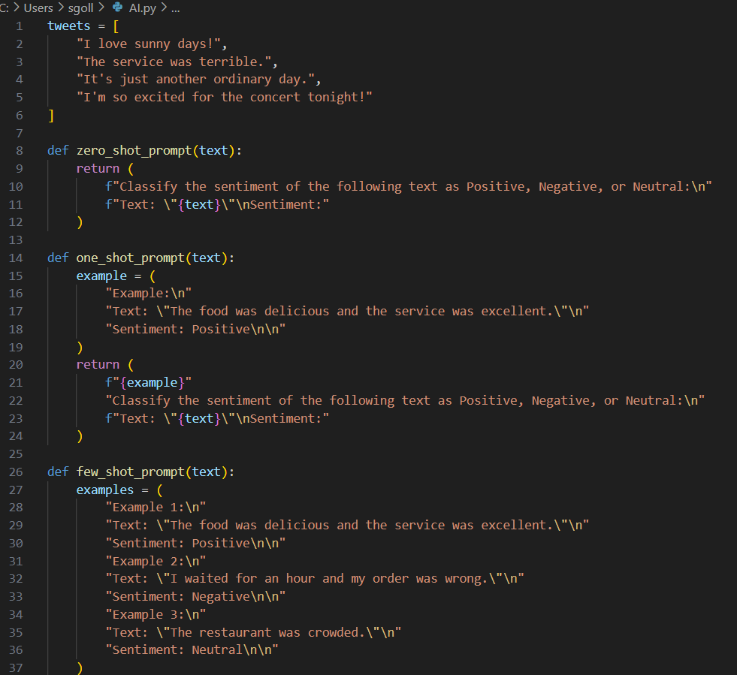

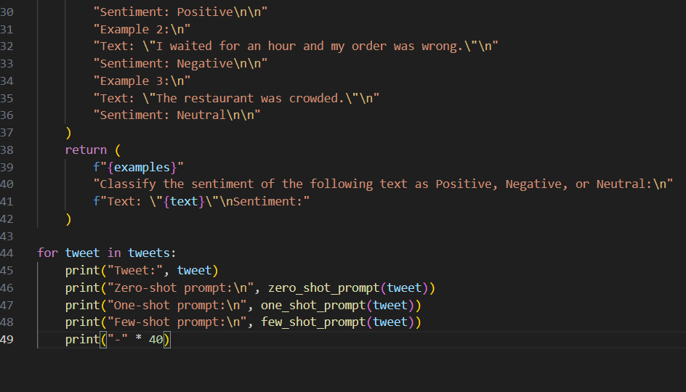

Output:

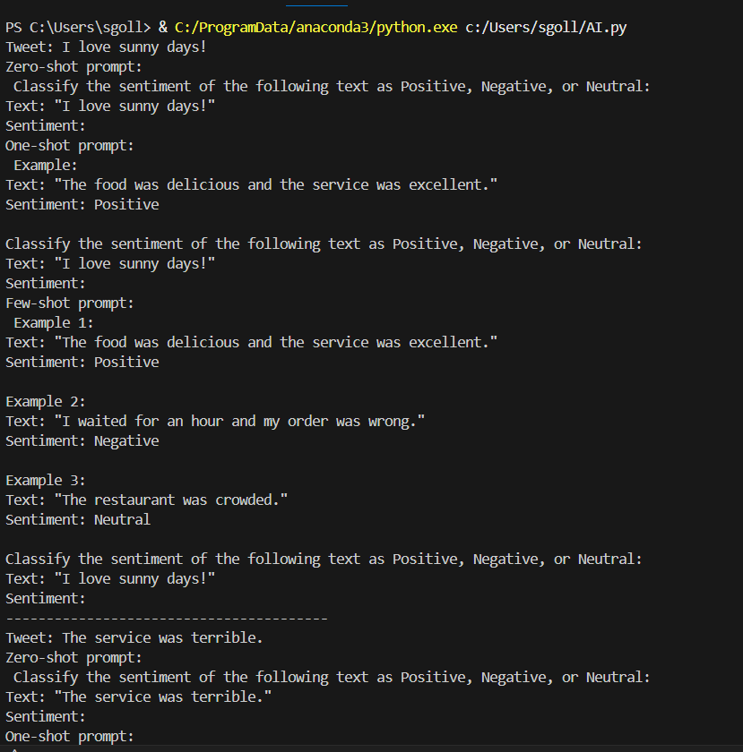

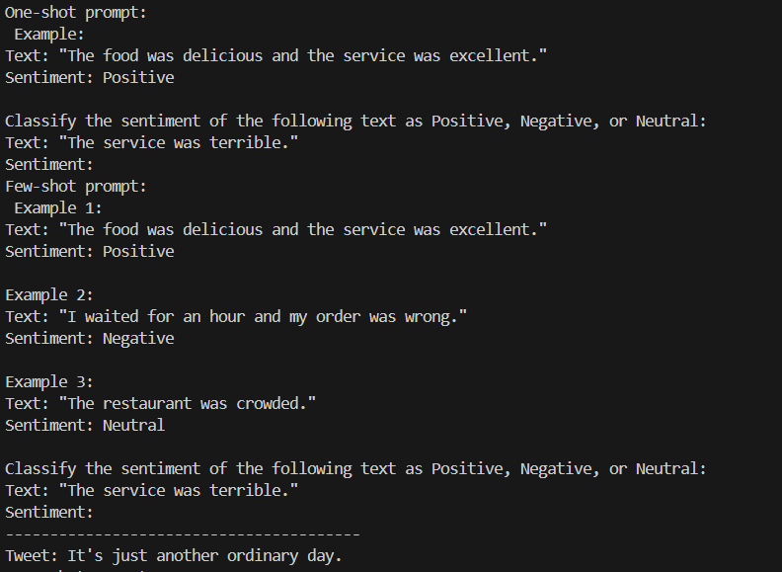

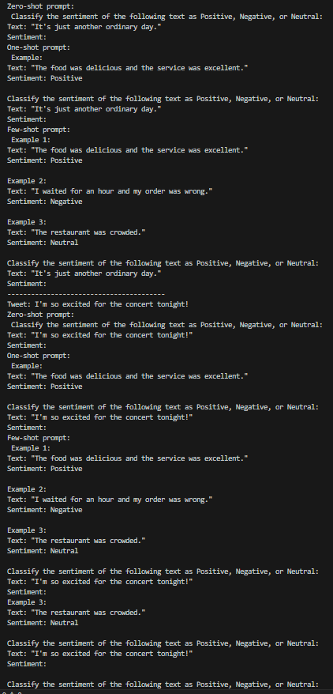

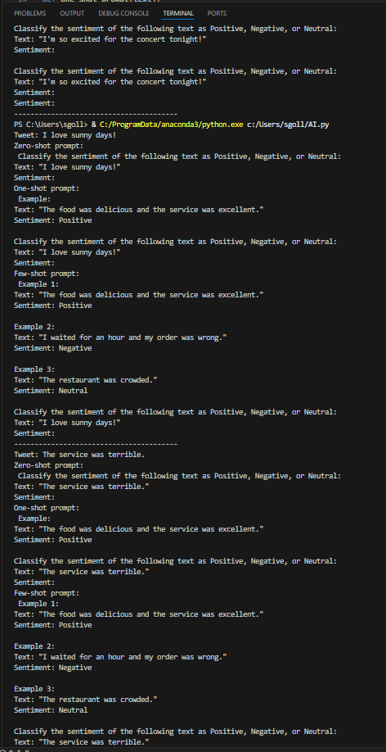

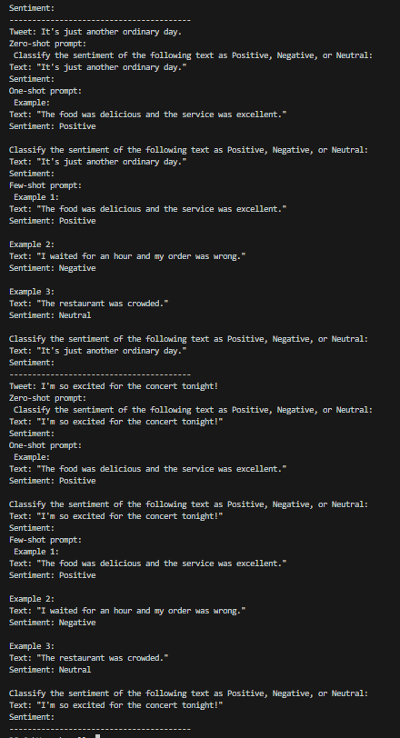

Observation:  
The code applies zero-shot, one-shot, and few-shot prompting methods to the same set of tweets for sentiment classification. Each prompt type provides a different level of guidance to the AI model: zero-shot gives no examples, one-shot gives one, and few-shot gives several. This setup allows you to compare how the number of examples affects the AI's understanding and accuracy. Typically, few-shot prompts lead to more reliable and context-aware outputs, while zero-shot may result in less consistent classifications.